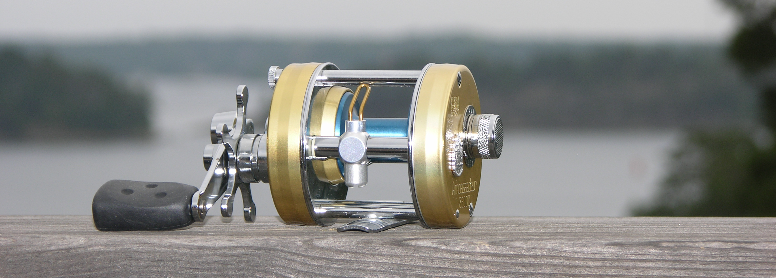
Congratulations to your new reel!

and thank you for choosing an Ambassadeur 2500C tuned by UT Reel Technology

Ambassadeur 2500C was at its introduction 1975 one of the most successful ABU reels ever made, well built and engineered for ultralight fishing. The spool bearings and the centrifugal breaking systems were both tailored to match the characteristics of that era’s monofilament line, vastly different from the braided lines typically used by today’s ultra-light anglers. The introduction of braided lines have completely changed the reels operating conditions, causing substantially more wear and tear on internal components, requiring a much more accurate spool control to avoid horrifying backlashes.
The drag system, with one single large diameter washer, was at the time considered extraordinary, but with today’s high expectations and use of braided lines it doesn’t really compare.

UT Reel Technology have completely disassembled the original reel and modified its construction, not only to address its known original weaknesses, but also in order to create a reel with true world-class performance characteristics, vastly exceeding what’s available in the market. This reel is specially tailored to be used in conjunction with braided lines, whilst being engineered and built to give its owner a life long trouble free angling experience and maximum pleasure.

Modifications:
The High-speed system (spool, spool bearings and levelwind system):

- The frame is a blue printed hard riveted frame out of cromed brass with a high angular accuracy in all critical dimensions.
- The spool is a super lightweight yet rugged aluminum spool, where the spool shaft has been carefully measured for straightness. One additional spool is supplied with the reel.
- The three spool bearings is a matched set of ceramic hybrids with metal parts of stainless steel and balls made out of a ceramic compound. The bearing tolerances are optimized for use with lures in the 3 - 40 grams range and is lubricated with a small amount of Rocket Fuel Yellow Label.
- The centrifugal breaking system is fitted with one midsized break-block when delivered, which is considered a good starting point for personal calibration. However, a set of break blocks of different sizes and weights are supplied, for a true optimization to the owner’s rod, casting technique and intended use.
- The idler gear is a weight reduced to achieve minimum inertia.
- The worm gears’s end bushings are low friction treated and lubricated with Rocket Fuel Yellow Label.
- The line winder is a light wheight linewinder with a line pawl out of ceramic material for maximum performance in all conditions.

Modifications:
The low speed system (crank, power train and drag system):
- The gear set has a ratio of 1:5,3.
- The drag system’s pressure plate is ground flat and the two dragwashers are taylor cut drag washers made of Carbon fiber. All surfaces are treated with a smallish amount of Cal’s 2speed reel grease before assembly, giving an ultra smooth, rugged, dependable drag system, reliable regardless of weather or temperarture.
- The IAR-bearing is cleaned and treated with a special lubrication to keep out water and moisture, securing max functionality over the widest possible temperature range and minimizing the risk for corrosion. An old style anti reverse dog is installed for extra safety, just in case…
- The handle is a single paddle with 35mm throw, the handle is fitted with a two ball bearing knob.

Calibration of the spool control system:
An Ambassadeur reel, tuned by UT Reel Technology, is a true high performance casting reel. Correctly calibrated, it outperforms everything else on the market in a comparable size. To achieve optimum performance, the reel should be calibrated to the angler, the baits, the rod and the line. Please consider a few rules of thumb and your fishing experience will be a true pleasure, completely trouble free even with braided lines.

The lightweight spool, the lightweight idler gear and the friction free bearings, makes the reel very responsive to calibration parameters such as amount of line on the spool, choice of centrifugal brake blocks and rod behaviour. But as long as the recommendations below are followed, you will within a few minutes have a safe and extremely easy handled reel even with lightweight baits you earlier never would consider using.

Line level: Fill the spool with your favourite line up to maximum 1,0 mm from the edge. Please notice that an over filled spool will make the reel nervous.
Centrifugal brake blocks: The reel is shipped with one medium sized fiber brake block on the reel, and a small plastic bag with small, medium and larger fiber blocks for calibration. The larger the brake block is, the more braking power you have. The starting point for calibration of your reel is one medium sized blocks mounted, even though most anglers typically would choose only one small when they feel confident with their reels.
Calibration: Mount the reel on your rod with a bait you normally use. Start off with 10 – 15 minutes casting in mild wind conditions to get a feeling for the reel. Set the mechanic brake set to zero. The system is designed to run with zero mechanic brake, even with light weight baits in moderate winds. If the reel feels “over braked” with one medium sized blocks and zero mechanic brake, shift to two small wheights. Next step would be only one small. You can also combine weights of different sizes to fine calibrate your reel. If the reel feels nervous with the two large blocks, check the line level and don’t hesitate to pull off 30 ft of line. This is very often the trick to calm down a nervous reel.

Periodic maintenance:
All parts are assembled with lubrications that have gone through numerous tests by UT Reel Technology. The reel is expected to work for long periods of time, with no more maintenance than a gentle wipe off with a damp cloth. After fishing in salt waters or in corrosive conditions, the reel should be gently rinsed under fresh water before wiped off. Salt water fishing is reducing the time between maintenance with ¼ of the recommendations below. Use of other lubricants than the recommended will have a negative impact on performance, maintenance frequency and life time.

Lubrication; high speed system:
Spool bearings: 1 – 2 times per year; remove the spool from the reel and oil them with Rocket Fuel Yellow Label.

Line winder system: After every tour, the worm gears bearings and the line winder track should get a drop of Rocket Fuel Yellow Label. More frequent lubrication does no harm.
1 – 2 times per year, disassemble the worm gear, the line winder and the line pawl, clean them and lubricate with Rocket Fuel Yellow Label. Clean the idler gear bearings and give them a drop of Rocket Fuel Yellow Label.

Lubrication; low speed system:
Nothing is needed as long as the reel is used for fresh water fishing. Salt water fishing requires regular tear down minimum once a year. But in case the drag gets jerky, the release mechanism doesn’t work or the reel has accidentally taken a bath, the crank side plate should be disassembled and thoroughly cleaned, let dry and lubricated with Cal’s Universal Reel and Star Drag Grease. The anti reverse bearing in the right outer side plate, should be washed in acetone or lighter fuel, let dry and then lubricated with Rocket Fuel Liquid Grease or a drop of high quality engine oil of grade 15W-40 or thicker.

Caution! Solvents is harmful to your health, work only in well ventilated areas designed for work with solvents.

