Ambassadeur 6500CS Chrome Rocket UT Edition
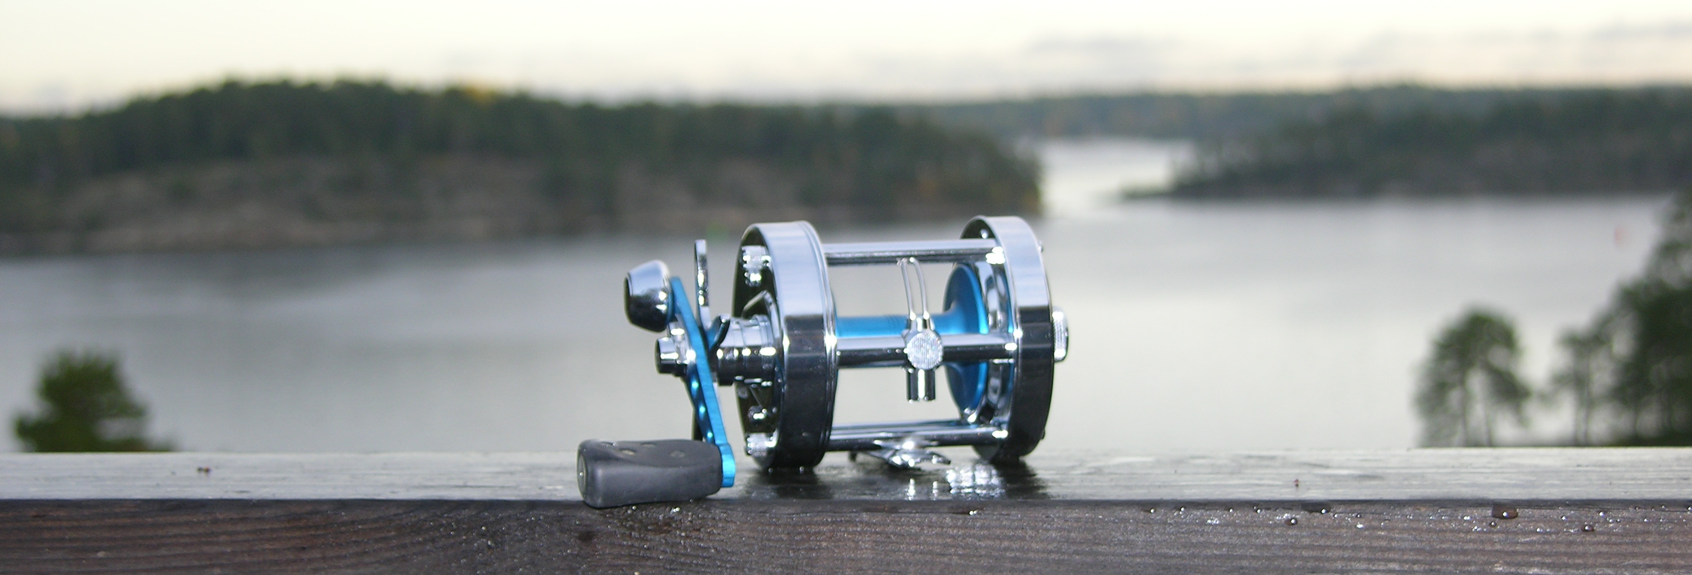
Ambassadeur 6500CS Chrome Rocket UT Edition, a high performance reel, modified for a life long trouble free angling experience.

Ambassadeur 6500CC Rocket was at its introduction in the end of the nineties a real step ahead for the surfcasting anglers in the world. A well built simple reel engineered for long distance casting. The spool bearings and the centrifugal breaking systems were both tailored to match the characteristics of that era’s monofilament line, vastly different from the braided lines typically used by today’s ultra-light anglers. The introduction of braided lines have completely changed the reels operating conditions, causing substantially more wear and tear on internal components, requiring a much more accurate spool control to avoid horrifying backlashes.
The drag system, was considered good when the reel was released, but with today’s high expectations and use of braided lines it doesn’t really compare.

UT Reel Technology have completely disassembled the original reel and modified its construction, not only to address its known original weaknesses, but also in order to create a reel with true world-class performance characteristics, vastly exceeding what’s available in the market. This reel is specially tailored to be used in conjunction with braided lines, whilst being engineered and built to give its owner a life long trouble free angling experience and maximum pleasure.

Modifications:
The High-speed system (spool, spool bearings and levelwind system):

- The frame is a blue printed hard riveted frame out of cromed brass.
- The spool is a super lightweight yet rugged aluminum spool, made out of Aluminium alloy 7075, hard as steel light as aluminium.
- The spool bearings is a matched pair of ceramic hybrids with metal parts of stainless steel and balls made out of a ceramic. The bearing tolerances are optimized for use with lures in the 15 - 100 grams range and is lubricated with Rocket Fuel Yellow Label.
- The Centrifugal braking system is a 6 brake block design. For best performance, the brake blocks are lubricated with Rocket Fuel Yellow Label. To get the full performance out of the reel, the owner needs to calibrate the reel to the rod, the intended baits and his casting style.
- The idler gear is weight reduced to achieve minimum inertia, and it has gone through a low friction treatment.
- The original worm gear bushings have gone through a special friction reduction treatment and are lubricated with Rocket Fuel Yellow Label. The worm gears line pawl trace is lubricated with Rocket Fuel Liquid Grease.
- The line pawl is exchanged to a ceramic line pawl for maximum ruggedness and lowest friction. The steel pawl is shipped with the reel as a spare part.

Modifications:
The low speed system (crank, power train and drag system):
- The gear set is made out of brass and has a 1:6,3 ratio for fastest retrieve.
- To match the gear ration, the reel has a custom single paddle crank with 45mm throw and a dual bearing paddle.
- The drag system is exchanged to UT Power Star Drag, a set of precision made drag washers out of carbon fiber and a set of metal washers made out of flat ground stainless steel. Before assembly, all surfaces are treated with a very small amount of Cal’s Universal Reel and Star Drag Grease, giving an ultra smooth, rugged, extremely capable, moisture and temperature independent drag system.
- The IAR-bearing is cleaned and treated with a special lubrication to keep out water and moisture, securing max functionality over the widest possible temperature range and minimizing the risk for corrosion. An old style anti reverse dog is installed on a dual supported pin, just in case…

Calibration of the spool control system:
An Ambassadeur reel, tuned by UT Reel Technology, is a true high performance casting reel. Correctly calibrated, it outperforms everything else on the market in a comparable size. To achieve optimum performance, the reel should be calibrated to the angler, the baits, the rod and the line. Please consider a few rules of thumb and your fishing experience will be a true pleasure, completely trouble free even with braided lines.

The lightweight spool, the lightweight idler gear and the friction free bearings, makes the reel very responsive to calibration parameters such as amount of line on the spool, choice of centrifugal brake blocks and rod behaviour. But as long as the recommendations below are followed, you will within a few minutes have a safe and extremely easy handled reel even with lightweight baits you earlier never would consider using.

Line level: Fill the spool with your favourite line up to 1/16 of an inch (1.5 mm) from the edge. Please notice that an over filled spool will make the reel nervous. Moreover; if less line is used on the spool, the reel can be used for very demanding baits, e.g. floating crank baits below 1/8 oz.
Centrifugal brake: The reel is shipped with non of the six snap-on/snapp-off brake blocks on the reel engaged. You need to snap off (engage) a few of the blocks before doing any casting. The recommended starting point for calibration of your reel is to engage all six blocks, even though most anglers typically would choose two to four blocks when they feel confident with their reels.
Calibration: Mount the reel on your rod with a bait you normally use. Start off with 10 – 15 minutes casting in mild wind conditions to get a feeling for the reel. Use the reel with the mechanic brake set to zero. The system is designed to run with zero mechanic brake, even with light weight baits in moderate winds. If the reel feels “over braked” with all six brake blocks engaged, snap on two blocks and continue doing so until the reel feels nervous. When you have hitted the nervous point, take a step back and engage one one more block and you are very well suited.
If the reel feels nervous with all six blocks engaged, check the line level and don’t hesitate to pull off 30 ft of line. This is very often the trick to calm down a nervous reel.
In wild waters, heavy rain or in cold damp weathers, it may happen that the reel gets nervous after an hour’s use. The reason is that the brake blocks and the runway are wet and the water is reducing the breaking power of centrifugal brake. This problem is addressed by a small drop of Rocket Fuel Yellow Label on the brake blocks

Periodic maintenance:
All parts are assembled with lubrications that have gone through numerous tests by UT Reel Technology. The reel is expected to work for long periods of time, with no more maintenance than a gentle wipe off with a damp cloth. After fishing in salt waters or in corrosive conditions, the reel should be gently rinsed under fresh water before wiped off. Salt water fishing is reducing the time between maintenance with ¼ of the recommendations below. Use of other lubricants than the recommended will have a negative impact on performance, maintenance frequency and life time.

Lubrication; high speed system:
Spool bearings: 1 – 2 times per year; remove the spool from the reel and oil them with Rocket Fuel Yellow Label.

Line winder system: After every 5th tour, the worm gears plastic bushings and the line winder track should get a drop of Rocket Fuel Yellow Label. More frequent lubrication does no harm.
1 – 2 times per year, disassemble the worm gear, the line winder and the line pawl, clean them and lubricate with Rocket Fuel Yellow Label. Give the idler gear a drop of Rocket Fuel Yellow Label at the shaft without removing it from its position.

Lubrication; low speed system:
Nothing is needed as long as the drag is smooth, the spool release system works fine and the retrieve is smooth. In case the drag gets jerky, the release mechanism doesn’t work or the reel has accidentally taken a bath, it should be disassembled and thoroughly cleaned, let dry and lubricated with a high quality marine grease. UT Reel Technology recommends Cal’s Universal Reel and Star Drag Grease. The anti reverse bearing in the right outer side plate, should be washed in acetone or lighter fuel, let dry and then lubricated with Rocket Fuel Liquid Grease or a drop of high quality engine oil of grade 15W-40 or thicker.

Caution! Solvents is harmful to your health, work only in well ventilated areas designed for work with solvents.

